 | Three Days Capacity Building Training Workshop  on |  |  | 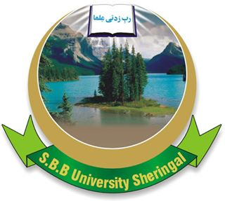
 |  | Advances in Research, Dissertation and Paper Writing in Biological Sciences  November 14−16, 2017 (Tuesday−Thursday)  Venue: Video Conferencing Room, SBBU | 
Name Prof./Dr/Mr/Miss/Ms: ____________________________________________

Department: ____________________________________________

Institution: ____________________________________________

Academic Title: ____________________________________________

Category: ____________________________________________
(Chairperson/Faculty/Student)

Address: ____________________________________________

City: ____________________________________________

Phone/Fax/email: ____________________________________________

Registration Fee: Faculty Members: Rs. 500/-; Students: Rs. 300/-
Note: Registration is limited, shall be on payment and will be done on the spot Tuesday 14th November 2017. Kindly confirm your registration by sending the form filled in all respects on or before 5th November 2017. Kindly inform about means of arrival and arrival time.
Chief Organizer: Dr. Farzana Khan Perveen, Chairperson

Shaheed Benazir Bhutto University (SBBU), Main Campus, Sheringal, Dir Upper (DU) Khyber Pakhtukhawa (KP), Pakistan
Contact Number & Email address
Mobile: +92-3002253872; 3002294834
Office Tel: +92-944-885415 (DOZ); +92-944-885479 (CE)
Fax: +92-944-885805 (Reg); +92-944-885503 (CE)
URL: http://www.sbbu.edu.pk; E.mail: farzana_san@hotmail.com

